LIST OF EXPERIMENTS

COURSE CODE: CSA37 NAME: ROSE MYSTICA J
COURSE NAME : SOFTWARE TESTING REG NO: 192421410

- Select any system, such as an ATM system, and thoroughly examine its system specifications to identify and document the different software defects present.
PROGRAM:
import java.util.Scanner;
public class ATMSystem {
public static void main(String[] args) {
Scanner sc = new Scanner(System.in);
int balance = 5000, pin = 1234;
System.out.print("Enter PIN: ");
int enteredPin = sc.nextInt();
if (enteredPin != pin) {
System.out.println("Defect Check: Invalid PIN");
} else {
System.out.print("Enter withdrawal amount: ");
int amount = sc.nextInt();
if (amount <= 0)
System.out.println("Defect: Invalid amount");
else if (amount > balance)
System.out.println("Defect: Insufficient balance");
else if (amount % 100 != 0)
System.out.println("Defect: Amount must be a multiple of 100");
else {
balance -= amount;
System.out.println("Withdrawal successful");
System.out.println("Remaining Balance: " + balance);
}
}
sc.close();
}
}
OUTPUT:
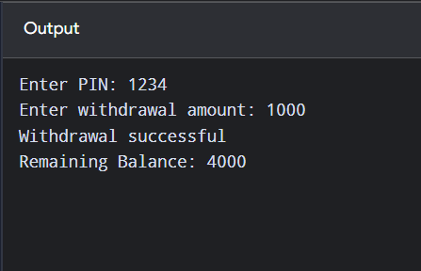
TEST CASES:
Bug ID | Bug Description | Steps to Reproduce | Expected Result | Actual Result | Status
ATM_BUG_01 | Valid card rejected | Insert a valid ATM card. | Welcome screen should appear. | Invalid card message appears. | Fail
ATM_BUG_02 | Valid PIN rejected | Insert a valid card and enter the correct PIN. | Main menu should appear. | Invalid PIN message appears. | Fail
ATM_BUG_03 | Account type error | Enter a valid PIN and select Savings or Current account. | Amount entry screen should appear. | Invalid account type message appears. | Fail
ATM_BUG_04 | Incorrect insufficient balance message | Enter a withdrawal amount within the available balance. | Transaction should proceed. | Insufficient balance message appears. | Fail
ATM_BUG_05 | Incorrect transaction limit error | Enter an amount within the per-transaction limit. | Cash should be dispensed. | Transaction limit exceeded message appears. | Fail
ATM_BUG_06 | Daily limit validation issue | Attempt a withdrawal exceeding the daily limit. | Transaction should be rejected with a daily limit message. | System dispenses cash despite the limit. | Fail
ATM_BUG_07 | Invalid denomination handling | Enter an amount that is not a multiple of the supported denomination, such as ₹150 when only ₹100 multiples are accepted. | Validation message should appear. | System accepts the invalid amount. | Fail
ATM_BUG_08 | Balance not updated | Complete a successful withdrawal. | Account balance should decrease by the withdrawal amount. | Balance remains unchanged. | Fail
ATM_BUG_09 | Cash not dispensed | Complete a withdrawal when sufficient funds and cash are available. | Cash should be dispensed successfully. | Transaction is approved, but no cash is dispensed. | Fail
ATM_BUG_10 | Session not terminated | Complete a transaction and select Exit. | Card/session should be safely terminated. | Session remains active. | Fail

- To write a case study to identify & analyze the requirements of Viana Portal and to write a positive Test Scenarios as well as Test cases for the above application.
PROGRAM:
public class VIANAPositive {
public static void main(String[] args) {
System.out.println("VIANA PORTAL POSITIVE TESTING");

System.out.println("TC01: Valid Login - Pass");
System.out.println("TC02: View Home Page - Pass");
System.out.println("TC03: View My Course - Pass");
System.out.println("TC04: Check Attendance - Pass");
System.out.println("TC05: View Assignment - Pass");
System.out.println("TC06: View Examination Details - Pass");
System.out.println("TC07: View Financial Record - Pass");
}
}
OUTPUT:
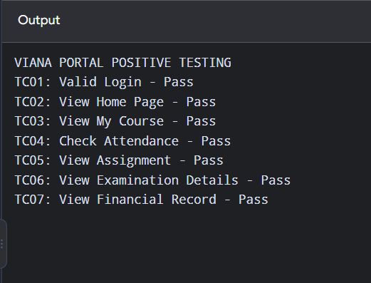
TEST CASES:
Test Case ID | Test Scenario | Test Steps / Test Data | Expected Result | Status
VIANA_TC_01 | Login to Portal | Open the Viana Study Portal and enter a valid username and password. Click Login. | User successfully logs in to the portal. | Pass
VIANA_TC_02 | View Dashboard | Log in and open the Dashboard. | Dashboard displays correctly. | Pass
VIANA_TC_03 | View Courses | Open the Courses section and select an available course. | Course details are displayed correctly. | Pass
VIANA_TC_04 | Access Study Materials | Open a course and select the available study material. | Study materials open or download successfully. | Pass
VIANA_TC_05 | View Assignments | Open the Assignments section and select an available assignment. | Assignment details and submission instructions are displayed. | Pass
VIANA_TC_06 | Submit Assignment | Upload a valid assignment file and click Submit. | Assignment is submitted successfully, and confirmation is displayed. | Pass
VIANA_TC_07 | View Attendance | Open the Attendance section. | Attendance details are displayed correctly. | Pass
VIANA_TC_08 | View Examination Details | Open the Examination section. | Examination schedules and related details are displayed correctly. | Pass
VIANA_TC_09 | View Results | Open the Results section. | Published examination results are displayed correctly. | Pass
VIANA_TC_10 | View Profile | Open My Profile. | User profile details are displayed correctly. | Pass

- To write a case study to identify & analyze the requirements of Viana Study Portal and to write a negative Test Scenarios as well as Test cases for the above application.
PROGRAM:
public class VIANANegative {
public static void main(String[] args) {
System.out.println("VIANA PORTAL NEGATIVE TESTING");

System.out.println("TC01: Invalid Username - Pass");
System.out.println("TC02: Invalid Password - Pass");
System.out.println("TC03: Empty Login Fields - Pass");
System.out.println("TC04: Unauthorized Page Access - Pass");
System.out.println("TC05: Invalid Attendance Request - Pass");
System.out.println("TC06: Invalid Payment Details - Pass");
}
}
OUTPUT:
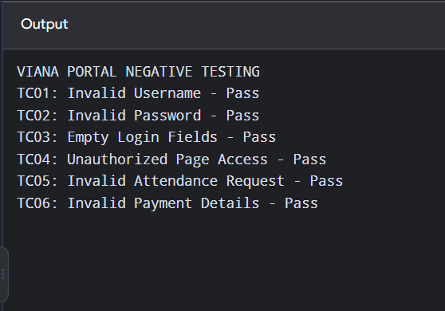
TEST CASES:
Test Case ID | Test Scenario | Test Steps / Test Data | Expected Result | Status
VIANA_NTC_01 | Login with invalid username | Enter an invalid username and a valid password. Click Login. | Error message should be displayed. | Pass
VIANA_NTC_02 | Login with invalid password | Enter a valid username and an incorrect password. Click Login. | Invalid password message should be displayed. | Pass
VIANA_NTC_03 | Login with empty fields | Leave the username and password fields empty. Click Login. | Required-field validation should be displayed. | Pass
VIANA_NTC_04 | Access dashboard without login | Try to open the dashboard without logging in. | User should be redirected to the login page. | Pass
VIANA_NTC_05 | Open unavailable course | Select a course that is unavailable or not assigned to the user. | Appropriate error or unavailable-course message should be displayed. | Pass
VIANA_NTC_06 | Submit assignment without a file | Open an assignment and click Submit without uploading a file. | Validation message should be displayed. | Pass
VIANA_NTC_07 | Upload invalid assignment file | Upload an unsupported file format. | The portal should reject the file and display an error message. | Pass
VIANA_NTC_08 | Access unpublished results | Open the Results section before results are published. | A message indicating that results are unavailable should be displayed. | Pass
VIANA_NTC_09 | Enter invalid profile details | Enter data in an incorrect format in a profile field. | Validation message should be displayed, and invalid data should not be saved. | Pass
VIANA_NTC_10 | Access restricted study material | Try to open study material without the required course access. | Access should be denied, and an appropriate message should be displayed. | Pass
- To write a case study to identify & analyze the requirements of e-Commerce Applications and to write a positive Test Scenarios as well as Test cases for the above application.
PROGRAM:
import java.util.Scanner;
public class EcommerceNegative {
public static void main(String[] args) {
Scanner sc = new Scanner(System.in);
System.out.println("E-COMMERCE NEGATIVE TESTING");
System.out.print("Enter product quantity: ");
int quantity = sc.nextInt();
System.out.print("Enter available stock: ");
int stock = sc.nextInt();
if (quantity <= 0) {
System.out.println("FAIL: Invalid quantity");
} else if (quantity > stock) {
System.out.println("FAIL: Product out of stock");
} else {
System.out.println("PASS: Product quantity accepted");
}
sc.close();
}
}

OUTPUT:
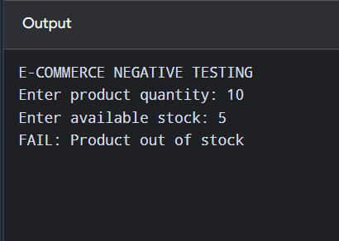
TEST CASES:
Test Case ID | Test Scenario | Test Steps / Test Data | Expected Result | Status
EC_PTC_01 | User Login | Enter valid username and password and click Login. | User logs in successfully. | Pass
EC_PTC_02 | Search Product | Enter a valid product name in the search bar. | Relevant products are displayed. | Pass
EC_PTC_03 | View Product Details | Select an available product. | Product name, price, and description are displayed. | Pass
EC_PTC_04 | Add to Cart | Select a product and click Add to Cart. | Product is added to the cart. | Pass
EC_PTC_05 | Update Quantity | Increase the quantity of a product in the cart. | Cart quantity and total price are updated correctly. | Pass
EC_PTC_06 | Apply Valid Coupon | Enter a valid discount coupon. | Discount is applied successfully. | Pass
EC_PTC_07 | Add Delivery Address | Enter a valid delivery address and save it. | Address is saved successfully. | Pass
EC_PTC_08 | Place Order | Select a product, provide the address, and confirm the order. | Order is placed successfully. | Pass
EC_PTC_09 | Make Payment | Select a payment method and complete a valid payment. | Payment is successful, and confirmation is displayed. | Pass
EC_PTC_10 | View Order History | Open My Orders after placing an order. | Order details and status are displayed correctly. | Pass

5. To write a case study to identify &amp; analyze the requirements of e- Commerce Applications and to write a negative Test Scenarios as well as Test cases for the above application.
PROGRAM:
import java.util.Scanner;
public class EcommerceNegative {
public static void main(String[] args) {
Scanner sc = new Scanner(System.in);
System.out.println("E-COMMERCE NEGATIVE TESTING");
System.out.print("Enter product quantity: ");
int quantity = sc.nextInt();

System.out.print("Enter available stock: ");
int stock = sc.nextInt();
System.out.print("Enter coupon code: ");
String coupon = sc.next();
if (quantity <= 0)
System.out.println("Invalid quantity");
else if (quantity > stock)
System.out.println("Product out of stock");
else
System.out.println("Quantity accepted");
if (!coupon.equals("SAVE10"))
System.out.println("Invalid coupon code");
else
System.out.println("Coupon applied");
sc.close();
}
}
OUTPUT:
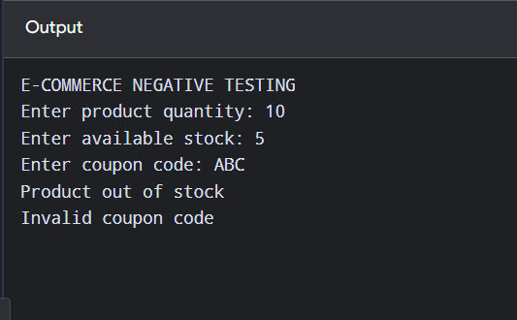
TEST CASES:
Test Case ID | Test Scenario | Test Steps / Test Data | Expected Result | Status
EC_NTC_01 | Login with Invalid Credentials | Enter an incorrect username or password. | Error message is displayed, and login is denied. | Pass
EC_NTC_02 | Search Invalid Product | Search for a product that does not exist. | No products found message is displayed. | Pass
EC_NTC_03 | Add Out-of-Stock Product | Try to add an unavailable product to the cart. | Product cannot be added, and an appropriate message is displayed. | Pass
EC_NTC_04 | Enter Invalid Quantity | Enter zero or a negative quantity. | Invalid quantity is rejected. | Pass
EC_NTC_05 | Apply Invalid Coupon | Enter an expired or invalid coupon code. | Coupon is rejected, and no discount is applied. | Pass
EC_NTC_06 | Submit Empty Address | Leave mandatory delivery address fields empty. | Required-field validation is displayed. | Pass
EC_NTC_07 | Make Payment with Invalid Details | Enter invalid payment information. | Payment is rejected, and an error message is displayed. | Pass
EC_NTC_08 | Place Order with Empty Cart | Try to place an order without adding products. | Order placement is prevented. | Pass
EC_NTC_09 | Exceed Available Stock | Enter a quantity greater than the available stock. | The system rejects the quantity or displays an appropriate stock warning. | Pass
EC_NTC_10 | Access Order Details Without Login | Try to open order history without logging in. | User is redirected to the login page or access is denied. | Pass

- To write a case study to identify & analyze the requirements of Food delivery Applications and to write a positive Test Scenarios as well as Testcases for the above application.
PROGRAM:
import java.util.Scanner;
public class FoodPositive {
public static void main(String[] args) {
Scanner sc = new Scanner(System.in);
System.out.println("FOOD DELIVERY POSITIVE TESTING");
System.out.print("Enter food item: ");
String food = sc.nextLine();
System.out.print("Enter quantity: ");
int quantity = sc.nextInt();
System.out.print("Enter price: ");
double price = sc.nextDouble();

if (!food.isEmpty() && quantity > 0 && price > 0) {
System.out.println("Food added successfully");
System.out.println("Food: " + food);
System.out.println("Quantity: " + quantity);
System.out.println("Total: " + (quantity * price));
} else {
System.out.println("Invalid order details");
}
sc.close();
}
}
OUTPUT:
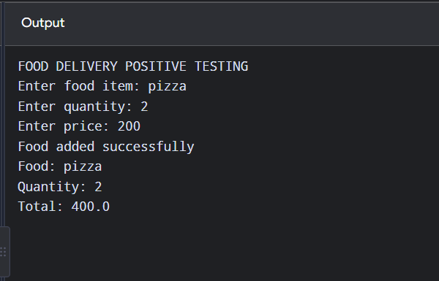
TEST CASES:
Test Case ID | Test Scenario | Test Steps / Test Data | Expected Result | Status
FDA_PTC_01 | User Login | Enter a valid username and password and click Login. | User logs in successfully. | Pass
FDA_PTC_02 | Search Restaurant | Enter a valid restaurant name in the search bar. | Matching restaurants are displayed. | Pass
FDA_PTC_03 | Search Food Item | Search for an available food item, such as Pizza. | Relevant food items are displayed. | Pass
FDA_PTC_04 | View Menu | Select a restaurant and open its menu. | Food items, prices, and descriptions are displayed. | Pass
FDA_PTC_05 | Add Food to Cart | Select a food item and click Add to Cart. | Selected food item is added to the cart. | Pass
FDA_PTC_06 | Update Food Quantity | Increase the quantity of a food item in the cart. | Quantity and total price are updated correctly. | Pass
FDA_PTC_07 | Apply Valid Coupon | Enter a valid discount coupon code. | Discount is applied successfully. | Pass
FDA_PTC_08 | Select Delivery Address | Enter and save a valid delivery address. | Delivery address is saved successfully. | Pass
FDA_PTC_09 | Place Food Order | Add food to the cart, select an address, and confirm the order. | Food order is placed successfully. | Pass
FDA_PTC_10 | Make Online Payment | Select an online payment method and complete payment using valid details. | Payment is successful, and confirmation is displayed. | Pass

- To write a case study to identify &amp; analyze the requirements of Food Delivery Applications and to write a negative ’1 est Scenarios as well as Testcases for the above application.
PROGRAM:
import java.util.Scanner;
public class FoodNegative {
public static void main(String[] args) {
Scanner sc = new Scanner(System.in);
System.out.println("FOOD DELIVERY NEGATIVE TESTING");
System.out.print("Enter food item: ");
String food = sc.nextLine();
System.out.print("Enter quantity: ");
int quantity = sc.nextInt();
System.out.print("Enter delivery distance in km: ");
double distance = sc.nextDouble();
if (food.isEmpty())
System.out.println("Food name cannot be empty");
else
System.out.println("Food name accepted");
if (quantity <= 0)
System.out.println("Invalid quantity");
else
System.out.println("Quantity accepted");
if (distance <= 0 || distance > 20)
System.out.println("Delivery unavailable");
else
System.out.println("Delivery available");
sc.close();
}
}
OUTPUT:
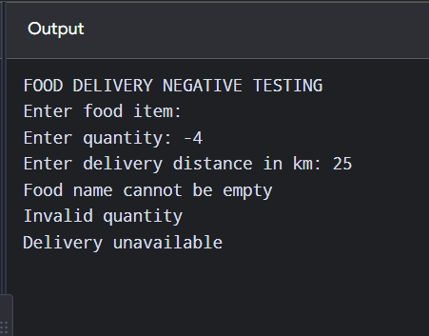
TEST CASES:
Test Case ID | Test Scenario | Test Steps / Test Data | Expected Result | Status
FDA_NTC_01 | Login with Invalid Credentials | Enter an incorrect username or password and click Login. | Error message is displayed, and login is denied. | Pass
FDA_NTC_02 | Search for Unavailable Food | Search for a food item that is not available. | A “No items found” message is displayed. | Pass
FDA_NTC_03 | Add Unavailable Food to Cart | Try to add an out-of-stock food item to the cart. | The item cannot be added, and an appropriate message is displayed. | Pass
FDA_NTC_04 | Enter Invalid Quantity | Enter zero or a negative quantity for a food item. | Invalid quantity is rejected. | Pass
FDA_NTC_05 | Apply Invalid Coupon | Enter an expired or invalid coupon code. | Coupon is rejected, and no discount is applied. | Pass
FDA_NTC_06 | Place Order with Empty Cart | Open the cart without adding food and click Checkout. | Order placement is prevented. | Pass
FDA_NTC_07 | Enter Incomplete Delivery Address | Leave mandatory address fields empty and click Continue. | Required-field validation is displayed. | Pass
FDA_NTC_08 | Make Payment with Invalid Details | Enter invalid payment details and attempt payment. | Payment is rejected, and an error message is displayed. | Pass
FDA_NTC_09 | Order from Unavailable Restaurant | Select a closed or unavailable restaurant and attempt to place an order. | Order placement is prevented, and an appropriate message is displayed. | Pass
FDA_NTC_10 | Exceed Available Food Quantity | Select a quantity greater than the available stock. | The application rejects the quantity or displays a stock warning. | Pass
- write a case study to identify & analyze the requirements of Banking Applications and to write a positive Test Scenarios as well as Test cases for the above application.
Objective:
PROGRAM:
import java.util.Scanner;
public class BankingPositive {
public static void main(String[] args) {
Scanner sc = new Scanner(System.in);
double balance = 5000;
System.out.println("BANKING POSITIVE TESTING");
System.out.println("Initial Balance: " + balance);
System.out.print("Enter deposit amount: ");
double deposit = sc.nextDouble();
if (deposit > 0) {
balance += deposit;
System.out.println("Deposit successful");
} else {
System.out.println("Invalid deposit");
}
System.out.print("Enter withdrawal amount: ");
double withdraw = sc.nextDouble();
if (withdraw > 0 && withdraw <= balance) {
balance -= withdraw;
System.out.println("Withdrawal successful");
} else {
System.out.println("Invalid withdrawal");
}
System.out.println("Final Balance: " + balance);
sc.close();
}
}
OUTPUT:
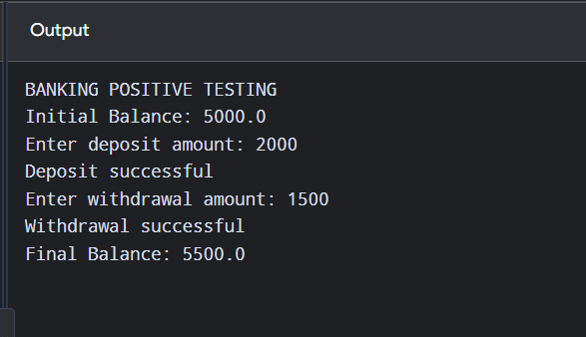
TEST CASES:
Test Case ID | Test Scenario | Test Steps / Test Data | Expected Result | Status
BANK_PTC_01 | Login with Valid Credentials | Enter a valid username and password. Click Login. | User logs in successfully. | Pass
BANK_PTC_02 | View Account Balance | Log in and select Account Balance. | Correct account balance is displayed. | Pass
BANK_PTC_03 | View Transaction History | Open the Transaction History section. | Recent transactions are displayed correctly. | Pass
BANK_PTC_04 | Transfer Money | Enter a valid beneficiary account number and transfer amount within the available balance. Confirm the transfer. | Money is transferred successfully, and confirmation is displayed. | Pass
BANK_PTC_05 | Deposit Money | Enter a valid deposit amount using the supported deposit method. | Deposit is processed successfully, and the balance is updated. | Pass
BANK_PTC_06 | Withdraw Money | Enter a valid withdrawal amount within the available balance and withdrawal limit. | Withdrawal is successful, and the balance is updated. | Pass
BANK_PTC_07 | Pay Bills | Select a registered biller, enter a valid amount, and confirm payment. | Bill payment is completed successfully. | Pass
BANK_PTC_08 | Add Beneficiary | Enter valid beneficiary details and complete the required verification. | Beneficiary is added successfully. | Pass
BANK_PTC_09 | Download Account Statement | Select an available date range and click Download Statement. | Account statement is downloaded successfully. | Pass
BANK_PTC_10 | Logout | Click the Logout button. | User is logged out and redirected to the login page. | Pass

- To write a case study to identify & analyze the requirements of Banking Applications and to write a negative Test Scenarios as well as Test cases for the above application.
PROGRAM:
import java.util.Scanner;
public class BankingNegative {
public static void main(String[] args) {
Scanner sc = new Scanner(System.in);
double balance = 5000;
System.out.println("BANKING NEGATIVE TESTING");
System.out.println("Available Balance: " + balance);
System.out.print("Enter withdrawal amount: ");
double amount = sc.nextDouble();
System.out.print("Enter account number: ");
String account = sc.next();
if (amount <= 0) {
System.out.println("Invalid withdrawal amount");
} else if (amount > balance) {
System.out.println("Insufficient balance");
} else {
balance -= amount;
System.out.println("Withdrawal successful");
}
if (!account.matches("[0-9]{10}")) {
System.out.println("Invalid account number");
} else {
System.out.println("Account number accepted");
}
sc.close();
}
}
OUTPUT:
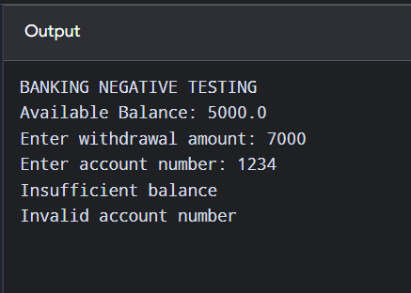
TEST CASES:
Test Case ID | Test Scenario | Test Steps / Test Data | Expected Result | Status
BANK_NTC_01 | Login with Invalid Credentials | Enter an incorrect username or password and click Login. | Error message is displayed, and login is denied. | Pass
BANK_NTC_02 | Login with Empty Fields | Leave username and password empty and click Login. | Required-field validation is displayed. | Pass
BANK_NTC_03 | Transfer to Invalid Account | Enter an invalid beneficiary account number and attempt a transfer. | Transfer is rejected, and an error message is displayed. | Pass
BANK_NTC_04 | Transfer Amount Exceeds Balance | Enter a transfer amount greater than the available balance. | Transfer is rejected due to insufficient funds. | Pass
BANK_NTC_05 | Withdraw Negative Amount | Enter a negative amount in the withdrawal field. | Invalid amount is rejected. | Pass
BANK_NTC_06 | Withdraw Above Daily Limit | Enter a withdrawal amount that exceeds the permitted daily limit. | Withdrawal is rejected, and a limit-exceeded message is displayed. | Pass
BANK_NTC_07 | Pay Bill with Invalid Details | Enter an invalid biller or payment reference. | Payment is rejected, and an error message is displayed. | Pass
BANK_NTC_08 | Add Beneficiary with Invalid Details | Enter an invalid beneficiary account number or required details. | Beneficiary registration is rejected. | Pass
BANK_NTC_09 | Download Statement with Invalid Date Range | Select an end date earlier than the start date. | Validation message is displayed, and the statement is not generated. | Pass
BANK_NTC_10 | Access Account Without Login | Attempt to open account details without logging in. | Access is denied, and the user is redirected to the login page. | Pass

- Develop a comprehensive test plan document for a chosen application, such as a Library Management System, outlining the various testing strategies, methodologies, and criteria to ensure thorough evaluation and validation of the system & functionality.
PROGRAM:
import java.util.*;
public class Main {
public static void main(String[] args) {
Scanner sc = new Scanner(System.in);
ArrayList<String> books = new ArrayList<>();
int choice;
do {
System.out.println("\n1.Add Book 2.Display Books 3.Search Book 4.Exit");
System.out.print("Enter choice: ");
choice = sc.nextInt();
sc.nextLine();
switch (choice) {
case 1:
System.out.print("Enter book name: ");
books.add(sc.nextLine());
System.out.println("Book Added");
break;
case 2:
System.out.println("Books: " + books);
break;
case 3:
System.out.print("Enter book name: ");
String name = sc.nextLine();
if (books.contains(name))
System.out.println("Book Found");
else
System.out.println("Book Not Found");
break;
case 4:
System.out.println("Exiting...");
break;
default:
System.out.println("Invalid Choice");
}
} while (choice != 4);
sc.close();
}
}
OUTPUT:
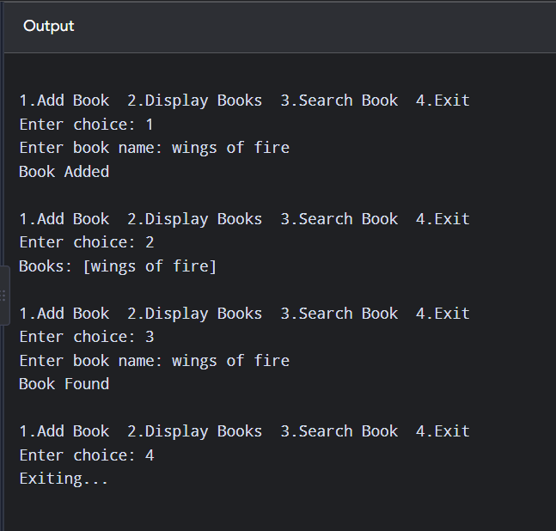

TEST CASE:
Test Case ID | Test Scenario | Test Steps / Test Data | Expected Result | Status
LMS_TC_01 | Valid Login | Enter valid username and password | Login successful | Pass
LMS_TC_02 | Invalid Login | Enter incorrect credentials | Error message displayed | Pass
LMS_TC_03 | Add a Book | Enter valid book details and click Add | Book is added successfully | Pass
LMS_TC_04 | Search a Book | Enter a valid book title | Matching book is displayed | Pass
LMS_TC_05 | Register a Member | Enter valid member details | Member is registered | Pass
LMS_TC_06 | Issue a Book | Select an available book and member | Book is issued successfully | Pass
LMS_TC_07 | Return a Book | Return an issued book | Book status changes to Available | Pass
LMS_TC_08 | Reserve a Book | Reserve a currently unavailable book | Reservation is recorded | Pass
LMS_TC_09 | Calculate Fine | Return a book after its due date | Correct fine is calculated | Pass
LMS_TC_10 | Delete a Book | Delete an eligible book record | Book is removed or marked inactive | Pass

11. Write a case study to identify and analyze the requirements of a Railway
Reservation System and prepare positive test scenarios and test cases for
the application.
PROGRAM:
public class RailwayReservationTest {
public static void main(String[] args) {
System.out.println("Railway Reservation System");
String source = "Chennai";
String destination = "Coimbatore";
if (!source.equals(destination)) {
System.out.println("TC01: Train Search - PASS");
}
int availableSeats = 10;
if (availableSeats > 0) {
availableSeats--;
System.out.println("TC02: Ticket Booking - PASS");
}
String name = "Arun";
int age = 20;
if (!name.isEmpty() && age > 0) {
System.out.println("TC03: Passenger Details - PASS");
}
boolean paymentSuccess = true;

if (paymentSuccess) {
System.out.println("TC04: Payment - PASS");
}
boolean ticketBooked = true;
if (ticketBooked) {
ticketBooked = false;
System.out.println("TC05: Ticket Cancellation - PASS");
}
}
}
OUTPUT:
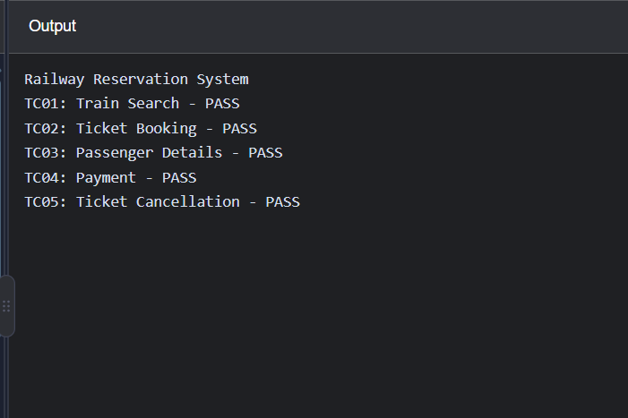
TEST CASES:
Test Case ID | Test Scenario | Test Steps / Test Data | Expected Result | Status
RAIL_PTC_01 | Register with Valid Details | Enter valid passenger details and click Register. | Account is created successfully. | Pass
RAIL_PTC_02 | Login with Valid Credentials | Enter a valid username and password and click Login. | User logs in successfully. | Pass
RAIL_PTC_03 | Search Trains | Enter source as Chennai and destination as Coimbatore. | Matching trains are displayed. | Pass
RAIL_PTC_04 | Search by Journey Date | Select a valid future journey date and search for trains. | Trains operating on the selected date are displayed. | Pass
RAIL_PTC_05 | Check Seat Availability | Select a train and click Check Availability. | Correct seat availability is displayed. | Pass
RAIL_PTC_06 | Enter Passenger Details | Enter valid passenger name, age, and gender. | Passenger details are accepted. | Pass
RAIL_PTC_07 | Book a Train Ticket | Select an available train and enter valid passenger details. | Ticket booking proceeds successfully. | Pass
RAIL_PTC_08 | Make Successful Payment | Select a supported payment method and complete the payment. | Payment is processed successfully. | Pass
RAIL_PTC_09 | Confirm Ticket Booking | Complete the booking and view the confirmation page. | PNR number and ticket details are generated. | Pass
RAIL_PTC_10 | View Booking History | Log in and open the booking history section. | Previous and current booking details are displayed. | Pass
RAIL_PTC_11 | Cancel a Booked Ticket | Select an eligible booked ticket and click Cancel. | Ticket is cancelled successfully. | Pass
RAIL_PTC_12 | Download Ticket | Open a confirmed ticket and click Download. | Ticket is downloaded successfully. | Pass

12. Write a case study to identify and analyze the requirements of a Railway Reservation System and prepare negative test scenarios and test cases for the application.
PROGRAM:
import java.util.Scanner;
public class Main {
public static void main(String[] args) {
Scanner sc = new Scanner(System.in);
System.out.print("Enter source station: ");
String source = sc.nextLine();
System.out.print("Enter destination station: ");
String destination = sc.nextLine();
System.out.print("Enter journey date (YYYY-MM-DD): ");
String date = sc.nextLine();
System.out.print("Enter passenger age: ");
int age = sc.nextInt();
System.out.print("Enter available seats: ");
int seats = sc.nextInt();
System.out.println("\n--- Negative Test Results ---");
if (source.isEmpty())
System.out.println("FAIL: Source station is required.");
else if (destination.isEmpty())
System.out.println("FAIL: Destination station is required.");
else if (source.equalsIgnoreCase(destination))
System.out.println("FAIL: Source and destination cannot be the same.");
else
System.out.println("PASS: Station details are valid.");
if (age < 0)
System.out.println("FAIL: Invalid passenger age.");
else
System.out.println("PASS: Passenger age is valid.");
if (seats <= 0)
System.out.println("FAIL: No seats available for booking.");
else
System.out.println("PASS: Seats are available.");
if (date.compareTo("2026-10-24") < 0)
System.out.println("FAIL: Journey date cannot be in the past.");
else
System.out.println("PASS: Journey date is valid.");
sc.close();
}
}
OUTPUT:
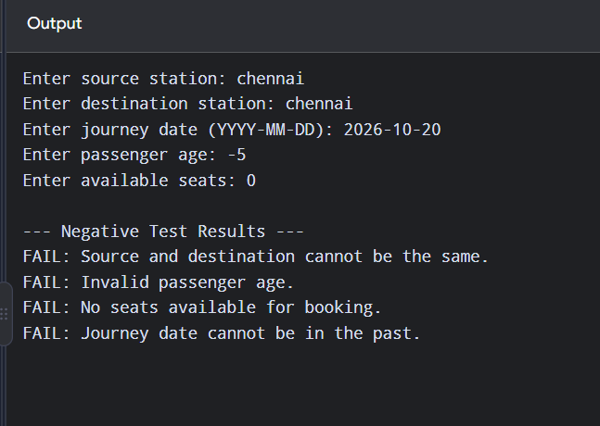
TEST CASES:
Test Case ID | Test Scenario | Test Steps / Test Data | Expected Result | Status
RRS_NTC_01 | Invalid login | Enter incorrect username and password | Display an error message | Pass
RRS_NTC_02 | Missing source station | Leave source station empty and search | Display validation message | Pass
RRS_NTC_03 | Same source and destination | Select Chennai as both stations | Display an error message | Pass
RRS_NTC_04 | Past journey date | Select a date before today | Reject the date and display a message | Pass
RRS_NTC_05 | Invalid passenger name | Enter numbers in the name field | Display validation message | Pass
RRS_NTC_06 | No seats available | Attempt booking when seats are unavailable | Prevent booking or show waitlist options | Pass
RRS_NTC_07 | Invalid payment details | Enter incorrect payment details | Display payment failure message | Pass
RRS_NTC_08 | Train not selected | Click Book without selecting a train | Display a validation message | Pass
RRS_NTC_09 | Invalid PNR number | Enter an incorrect PNR for cancellation | Display ticket-not-found message | Pass
RRS_NTC_10 | Invalid passenger age | Enter a negative age | Reject the age and display a validation message | Pass

13.Write a case study to identify and analyze the requirements of an Online Examination System and prepare positive test scenarios and test cases for the application.
PROGRAM:
import java.util.Scanner;
public class Main {
public static void main(String[] args) {
Scanner sc = new Scanner(System.in);
System.out.print("Enter username: ");
String username = sc.nextLine();
System.out.print("Enter password: ");
String password = sc.nextLine();

if (username.equals("student") && password.equals("1234")) {
System.out.println("Login Successful!");
System.out.println("Online Examination Started");
int score = 0;
System.out.println("\n1. Java is a programming language?");
System.out.println("1. Yes 2. No");
System.out.print("Enter answer: ");
if (sc.nextInt() == 1)
score++;
System.out.println("\n2. Which keyword creates a class in Java?");
System.out.println("1. method 2. class 3. define");
System.out.print("Enter answer: ");
if (sc.nextInt() == 2)
score++;
System.out.println("\nExam Submitted Successfully!");
System.out.println("Total Marks: " + score + "/2");
System.out.println("Result: " + (score >= 1 ? "Pass" : "Fail"));
} else {
System.out.println("Login Failed");
}
sc.close();
}
}

OUTPUT:
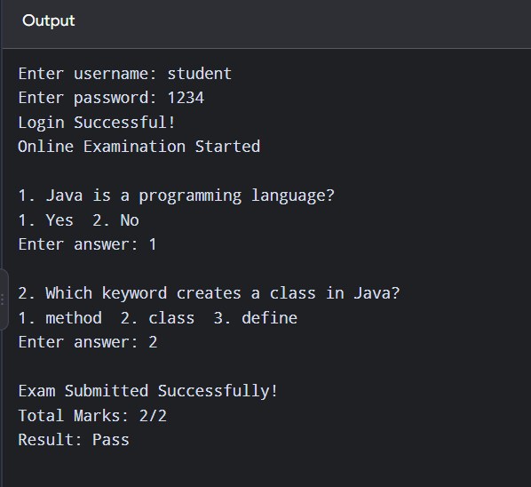
TEST CASES:
Test Case ID | Test Scenario | Test Steps / Test Data | Expected Result | Status
OES_PTC_01 | Valid login | Enter valid username and password | Student logs in successfully | Pass
OES_PTC_02 | View examinations | Open the examination list | Available exams are displayed | Pass
OES_PTC_03 | Start exam | Select an available examination and click Start | Examination begins successfully | Pass
OES_PTC_04 | Display questions | Open the exam question page | Questions and options are displayed | Pass
OES_PTC_05 | Select answer | Select an option for a question | Answer is selected successfully | Pass
OES_PTC_06 | Navigate questions | Click Next and Previous | Questions are displayed correctly | Pass
OES_PTC_07 | Save answers | Select an answer and save it | Answer is saved successfully | Pass
OES_PTC_08 | Submit examination | Answer questions and click Submit | Examination is submitted successfully | Pass
OES_PTC_09 | Calculate score | Submit answers with known correct responses | Score is calculated accurately | Pass
OES_PTC_10 | View results | Open the result page after evaluation | Marks and result are displayed correctly | Pass

14.Write a case study to identify and analyze the requirements of an Online Examination System and prepare negative test scenarios and test cases for the application.
PROGRAM:
import java.util.Scanner;
public class OnlineExaminationSystem {
public static void main(String[] args) {
Scanner sc = new Scanner(System.in);
System.out.print("Enter Username: ");
String username = sc.nextLine();

System.out.print("Enter Password: ");
String password = sc.nextLine();
if (username.isEmpty() || password.isEmpty()) {
System.out.println("FAIL: Username or password cannot be empty");
} else if (!username.equals("student") ||
!password.equals("1234")) {
System.out.println("FAIL: Invalid username or password");
} else {
System.out.println("Login Successful");
System.out.print("Enter number of questions: ");
int questions = sc.nextInt();
if (questions <= 0) {
System.out.println("FAIL: Invalid number of questions");
} else {
System.out.print("Enter exam duration in minutes: ");
int duration = sc.nextInt();
if (duration <= 0) {
System.out.println("FAIL: Invalid exam duration");
} else {
System.out.println("Exam Started");
}
}
}
sc.close();
}
}
OUTPUT:
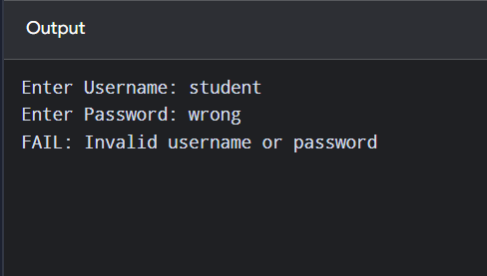
TEST CASES:
Test Case ID | Test Scenario | Test Data | Expected Result | Status
OES_NTC_01 | Empty username | Username: Empty | Error message displayed | Pass
OES_NTC_02 | Empty password | Password: Empty | Error message displayed | Pass
OES_NTC_03 | Invalid username | Username: abc, Password: 1234 | Invalid credentials message | Pass
OES_NTC_04 | Invalid password | Username: student, Password: wrong | Invalid credentials message | Pass
OES_NTC_05 | Both credentials invalid | Username: abc, Password: xyz | Invalid credentials message | Pass
OES_NTC_06 | Zero questions | Questions: 0 | Invalid number of questions message | Pass
OES_NTC_07 | Negative questions | Questions: -5 | Invalid number of questions message | Pass
OES_NTC_08 | Zero exam duration | Duration: 0 | Invalid exam duration message | Pass
OES_NTC_09 | Negative exam duration | Duration: -10 | Invalid exam duration message | Pass
OES_NTC_10 | Valid login and exam details | Username: student, Password: 1234, Questions: 10, Duration: 30 | Exam started successfully | Pass

15.Develop a comprehensive Test Plan document for an Inventory Management System, covering test scope, test design techniques, test execution strategy, and test completion criteria.
PROGRAM:
import java.util.Scanner;
public class InventoryManagementSystem {
public static void main(String[] args) {
Scanner sc = new Scanner(System.in);
System.out.println("INVENTORY MANAGEMENT SYSTEM");
System.out.print("Enter Product Name: ");
String name = sc.nextLine();
System.out.print("Enter Stock Quantity: ");
int quantity = sc.nextInt();

System.out.print("Enter Product Price: ");
double price = sc.nextDouble();
if (name.isEmpty()) {
System.out.println("Error: Product name cannot be empty");
} else if (quantity < 0) {
System.out.println("Error: Invalid stock quantity");
} else if (price <= 0) {
System.out.println("Error: Invalid product price");
} else {
System.out.println("\nProduct Added Successfully");
System.out.println("Product Name: " + name);
System.out.println("Stock Quantity: " + quantity);
System.out.println("Product Price: " + price);
System.out.println("Total Value: " + (quantity * price));
if (quantity < 5) {
System.out.println("Low Stock Alert!");
}
}
sc.close();
}
}
OUTPUT:
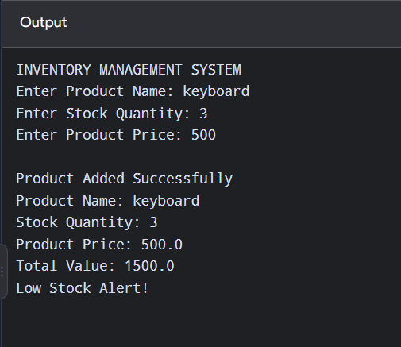

TEST CASES:
Test Case ID | Test Scenario | Test Data | Expected Result | Status
IMS_TC_01 | Add valid product | Keyboard, Quantity: 10, Price: 500 | Product added successfully | Pass
IMS_TC_02 | Enter empty product name | Name: Empty | Error message displayed | Pass
IMS_TC_03 | Enter negative stock quantity | Quantity: -5 | Invalid stock quantity message | Pass
IMS_TC_04 | Enter zero product price | Price: 0 | Invalid product price message | Pass
IMS_TC_05 | Enter negative product price | Price: -100 | Invalid product price message | Pass
IMS_TC_06 | Calculate total inventory value | Quantity: 10, Price: 500 | Total value displayed as 5000 | Pass
IMS_TC_07 | Check low-stock alert | Quantity: 3 | Low Stock Alert displayed | Pass
IMS_TC_08 | Check normal stock quantity | Quantity: 20 | Product details displayed without low-stock alert | Pass
IMS_TC_09 | Add product with zero stock | Quantity: 0, Price: 500 | Product added and low-stock alert displayed | Pass
IMS_TC_10 | Add product with valid details | Mouse, Quantity: 15, Price: 300 | Product details and total value displayed | Pass

